CERTIFICATE
To : HUNG XUONG COMPANY LTD.

Here we guarantee our product AN-45、ASD-350、C-90L、CAA-100、CD-65、CK-100、CWH、JS-200、KC-100R、MC、PES、RO、RD-400、RP-102、RP-123、RP-450、SA-62、TA-315、A-100、A-500、AT-120、AT-320、PAN、PES-200、PS-360、PM-515、NL-420、RA-400、AB、AM-175、CAT-1、CB-400、NF-100、CD-45、RA-200、CB-260、AB-100、HES-250、POS-300、PTS-110、TA-300、W、POS-100、PAS-200、DF、NY-601、NY-200、JS-860 do not contain any restricted substances listed as follow.

- APEO
- NPEO
- LAS
- DTDMAC
- DSDMAC
- DHTDMAC
- DTPA
- EDTA
- Pentachlorophenol(PCP)
- Terachloroophenol(TECP)
- Polychorinated(PCB)
- Organic Solvent

- Chlorinated Organic Carrier
- Organictin
- Lindane
- Azodyes / Carcinogenic Arylamine

Please make the same guarantee to your customers depends on this certificate.

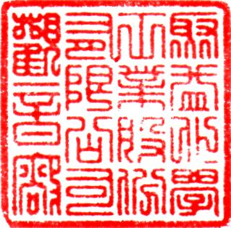
Company：

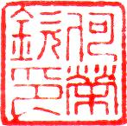
Manager：

Address：RM. 1001, FL. 10, NO. 15,
FU-HSING N RD., TAIPEI, TAIWAN 2007/07/27

